**Experiment 1:**

For financial dataset:

**Model 1: Simple Glove Embedding learning from Data**

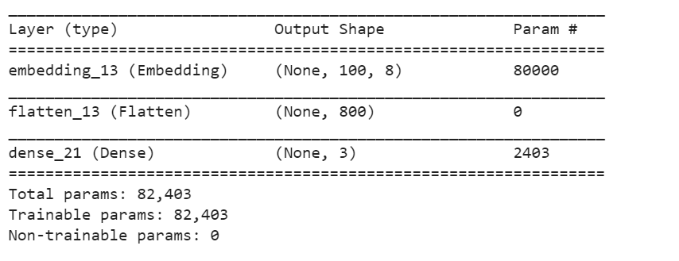

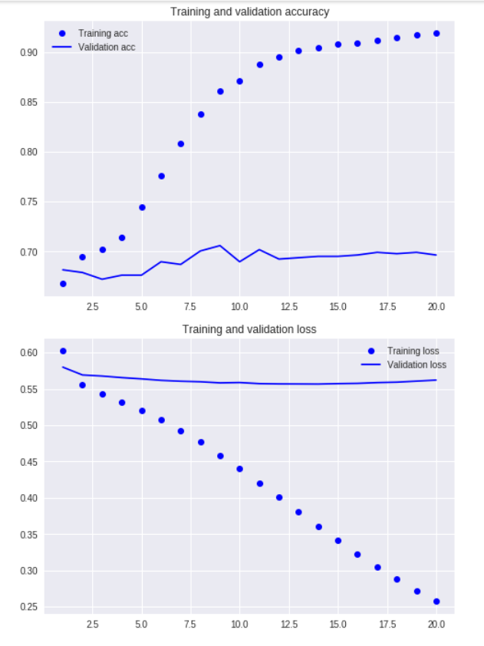**The result after 20 epochs**

**Model2: Glove model with pre-trained weights**

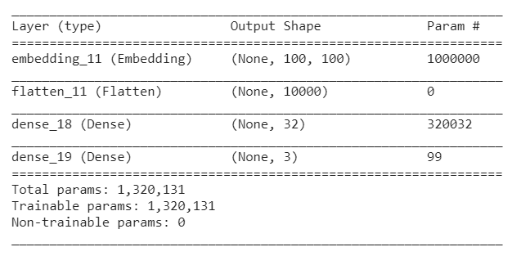



**Result after 20 epochs**

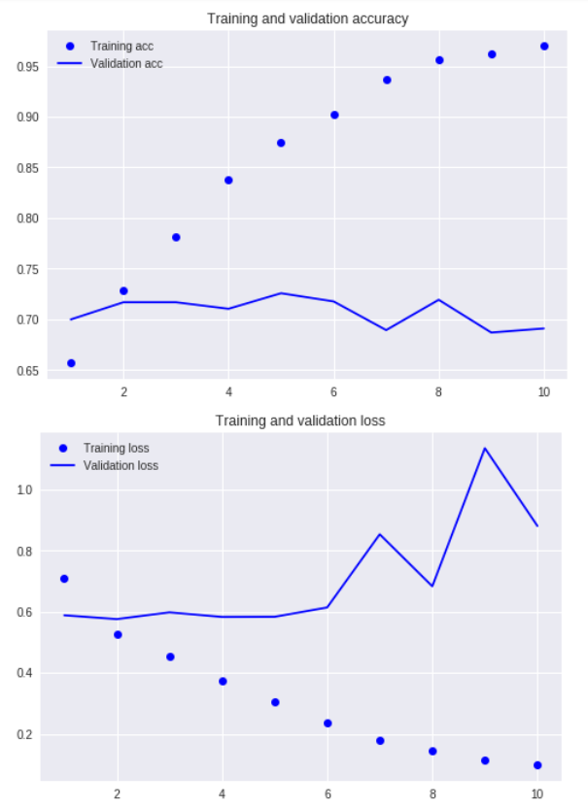

**Model 3: Tuning the glove model**



**Result after 10 epochs**

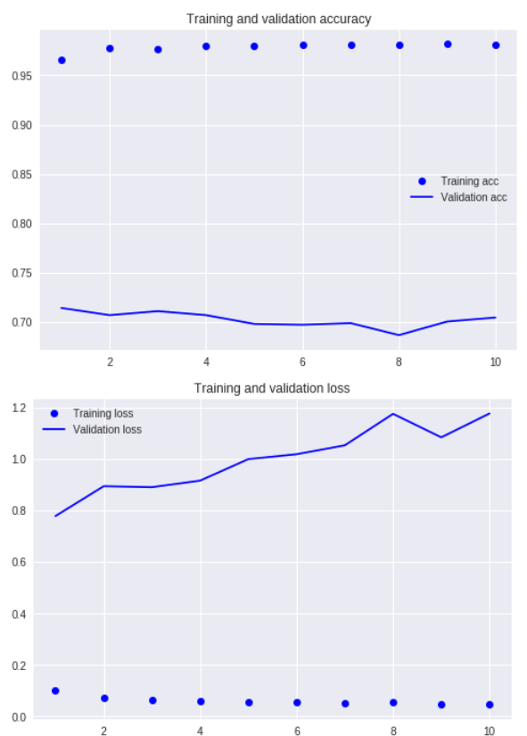

The best model was seen when the pre-trained weights are used and the model is not tuned.

**Confusion matrix for the best model:**

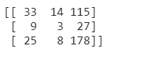

The model looks biased in all the cases, it may be due to the unbalanced data provided to the network.